**Chapter 5**

**Sequences and Series**

**5.5 Alternating Series**

**Section Exercises**

**State whether each of the following series converges absolutely, conditionally, or not at all.**

251. 

Answer: Does not converge by divergence test. Terms do not tend to zero.

253. 

Answer: Converges conditionally by alternating series test, since  is decreasing. Does not converge absolutely by comparison with *p*-series, 

255. 

Answer: Converges absolutely by limit comparison to  for example.

257. 

Answer: Diverges by divergence test since 

259. 

Answer: Does not converge. Terms do not tend to zero.

261. 

Answer:  Diverges by divergence test.

263. 

Answer: Converges by alternating series test.

265. 

Answer: Converges conditionally by alternating series test. Does not converge absolutely by limit comparison with *p*-series, 

267. 

Answer: Diverges; terms do not tend to zero.

269.  (*Hint:*  for large )

Answer: Converges by alternating series test. Does not converge absolutely by limit comparison with harmonic series.

271.  (*Hint:* Cross-multiply then rationalize numerator.)

Answer: Converges absolutely by limit comparison with *p*-series,  after applying the hint.

273.  (*Hint:* Use Mean Value Theorem.)

Answer: Converges by alternating series test since  is decreasing to zero for large  Does not converge absolutely by limit comparison with harmonic series after applying hint.

275. 

Answer: Converges absolutely, since  are terms of a telescoping series.

277. 

Answer: Terms do not tend to zero. Series diverges by divergence test.

279. 

Answer: Converges by alternating series test. Does not converge absolutely by limit comparison with harmonic series.

**In each of the following problems, use the estimate  to find a value of  that guarantees that the sum of the first  terms of the alternating series  differs from the infinite sum by at most the given error. Calculate the partial sum  for this**

281. **[T]**   error 

Answer:    

283. **[T]**  error 

Answer:  or  or  

285. **[T]**  error 

Answer:  or  

**For the following exercises, indicate whether each of the following statements is true or false. If the statement is false, provide an example in which it is false.**

287. If  is decreasing, then  converges absolutely.

Answer: True.  need not tend to zero since if  then 

289. If  is decreasing and  converges then  converges.

Answer: True.  so convergence of  follows from the comparison test.

291. Let  if  and  if  (Also,  and  If  converges conditionally but not absolutely, then neither  nor  converge.

Answer: True. If one converges, then so must the other, implying absolute convergence.

293. Suppose that  is a sequence such that  converges for every possible sequence  of zeros and ones. Does  converge absolutely?

Answer: Yes. Take  if  and  if  Then  converges. Similarly, one can show  converges. Since both series converge, the series must converge absolutely.

**The following series do not satisfy the hypotheses of the alternating series test as stated.**

**In each case, state which hypothesis is not satisfied. State whether the series converges absolutely.**

295. 

Answer: Not decreasing. Does not converge absolutely.

297. 

Answer: Not alternating. Can be expressed as  which diverges by comparison with 

299. Suppose that  converges absolutely. Show that the series consisting of the positive terms  also converges.

Answer: Let  if  and  if  Then  for all  so the sequence of partial sums of  is increasing and bounded above by the sequence of partial sums of  which converges; hence,  converges.

301. The formula  will be derived in the next chapter. Use the remainder  to find a bound for the error in estimating  by the fifth partial sum  for   and 

Answer: For  one has  When   When   When  

303. How many terms in  are needed to approximate  accurate to an error of at most 

Answer: Let  Then  when  or  and  whereas 

305. Sometimes the alternating series  converges to a certain fraction of an absolutely convergent series  at a faster rate. Given that  find  Which of the series  and  gives a better estimation of  using  terms?

Answer: Let  Then  so   

 The alternating series is more accurate for  terms.

**The following alternating series converge to given multiples of  Find the value of  predicted by the remainder estimate such that the  partial sum of the series accurately approximates the left-hand side to within the given error. Find the minimum  for which the error bound holds, and give the desired approximate value in each case. Up to  decimals places,**

307. **[T]**  error 

Answer:  

309. **[T]** If  what is 

Answer: The partial sum is the same as that for the alternating harmonic series.

311. [**T]** Plot the series  for  and comment on its behavior

Answer: The series jumps rapidly near the endpoints. For  away from the endpoints, the graph looks like 

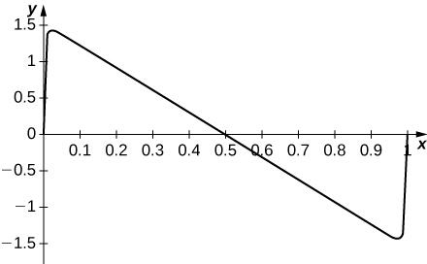

313. **[T]** The alternating harmonic series converges because of cancellation among its terms. Its sum is known because the cancellation can be described explicitly. A random harmonic series is one of the form  where  is a randomly generated sequence of  in which the values  are equally likely to occur. Use a random number generator to produce  random  and plot the partial sums  of your random harmonic sequence for  to  Compare to a plot of the first  partial sums of the harmonic series.

Answer: Here is a typical result. The top curve consists of partial sums of the harmonic series. The bottom curve plots partial sums of a random harmonic series.

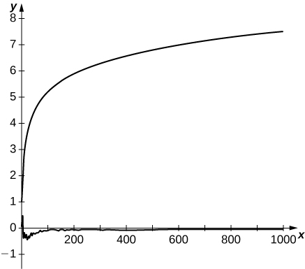

315. [**T]** The *Euler transform* rewrites  as  For the alternating harmonic series, it takes the form  Compute partial sums of  until they approximate  accurate to within  How many terms are needed? Compare this answer to the number of terms of the alternating harmonic series are needed to estimate 

Answer: By the alternating series test,  so one needs  terms of the alternating harmonic series to estimate  to within  The first  partial sums of the series  are (up to four decimals)  and the tenth partial sum is within  of 

This file is copyright 2016, Rice University. All Rights Reserved.